TGEN153 Introduction to Operating Systems

May 2024

Group Assignment

Configuration with Fedora Linux

PHOON YEW FAI 2370265-DCS

DANERSON TEH JIE SHENG 2370276-DCS

LAI JUN CHENG 2370293-DCS

WONG WENG HONG 2390009-DCS

MR LEE JIA KHANG

Table of Content

|  |  |  |
| --- | --- | --- |
| No. | Content | Pages |
| 1 | Table of Content | 2 |
| 2 | Introduction | 3 |
| 3 | SSH Configuration on Fedora Linux | 3~6 |
| 4 | Firewall Configuration on Fedora Linux | 7~11 |
| 5 | MySQL Configuration on Fedora Linux | 12~15 |
| 6 | Git Configuration & Usage on Fedora Linux | 16~19 |
| 7 | Reference | 20 |

Introduction

Fedora Linux is a Linux OS that’s being used for this report. In this report, ways to configure Fedora Linux will be demonstrated as a demonstration. This report will include SSH configuration, firewall configuration, MySQL configuration and Git configuration.

SSH Configuration on Fedora Linux

1. Firstly, Boot up Fedora Linux.

1. Afterwards, open terminal to start configuration.
2. Run the command below for installing ssh server inside Fedora Linux.



1. It will ask for password for safety reason for preventing user not knowing the usage.

1. After that, the command below have to be run for enabling SSH.



1. Once SSH is enabled, the command below will be inputed to start the SSH server.



1. To check that SSH is started, run “sudo systemctl status sshd”. It should show the result as demonstrated below:

1. After starting the SSH, the command below should be ran for locating the IP of the device.



It should be displayed as below, look for the IP that’s at the right of the 2nd row of number 2. (The IP I have is 192.168.0.184)

1. Once the IP is located, go to another device to run the command below for accessing the SSH server you’ve started. (host@ip)



The other device that’s used are running in Windows 11 OS, thus it works with latest Windows OS.

1. After your first access, the SSH server will request for verification towards the access of SSH server in Fedora Linux.

Once “yes” with the fingerprint is keyed in, the SSH server will automatically add the device’s IP into the Window OS.

1. Once the password is keyed, thus another device will have access to the Fedora Linux SSH.

Example control towards SSH server:

* Viewing the IP address of the SSH server

* Installing Git into SSH server (It was installed thus it only show that it’s been installed)

* Updating Fedora Linux via SSH remote configuration

* Reboot the remoted device via remote configuration

Firewall Configuration on Fedora Linux

**Fedora Linux Firewall configuration:**

**Check Firewall service running state:**

Code: Sudo systemctl status firewalld

**Terminate Firewall services:**

Code: Sudo systemctl stop firewalld

**Restart Firewall:**

Code: Sudo systemctl restart firewalld

**List available services:**

Code: Sudo firewall-cmd –list-all

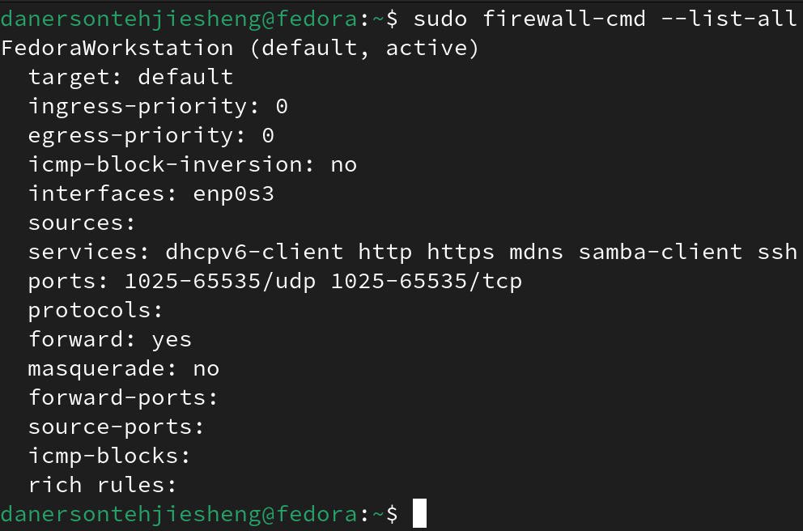

**Add new service:**

Code: Sudo firewall-cmd –add-services=ssh –permanent

Sudo firewall-cmd --reload

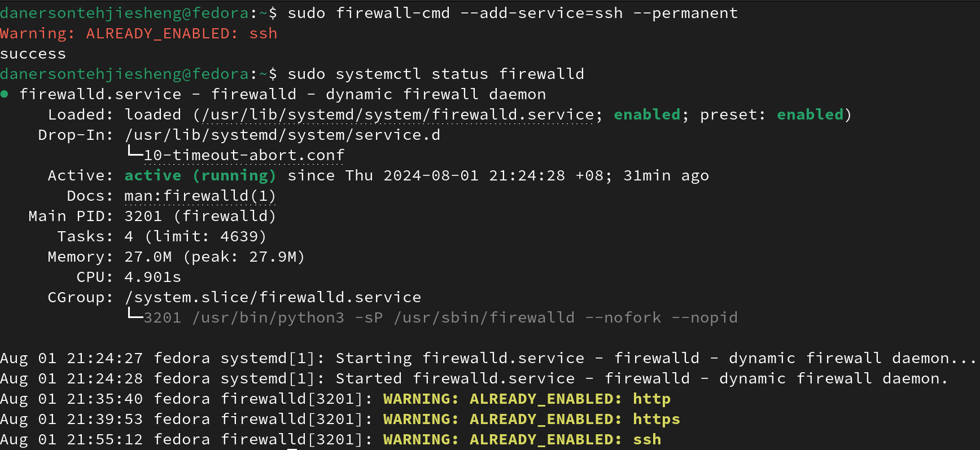

**Remove service**:

Code: Sudo firewall-cmd –remove-service=ssh --permanent

Sudo firewall-cmd --reload

**Add new port:**

Code: Sudo firewall-cmd --add-port=9090/tcp --permanent

Sudo firewall-cmd --reload

**Remove port:**

Code: Sudo firewall-cmd -remove-port=9090/tco –permanent

Sudo firewall-cmd --reload

**Allowing IP address:**

Code: Sudo firewall-cmd –permanent –add-rich-rule “ rule family= ‘ipv4’ source address=’192.168.1.100’ accept”

Sudo firewall-cmd –reload

**Rejecting IP address:**

Code: Sudo firewall-cmd -permanent-add-rich-rule “ rule family=’ipv4’ source address=’192.168.1.100’ reject”

Sudo firewall-cmd –reload

Mysql configuration(fedora)

1.Code: Sudo dnf update

Update the os service to the latest date.

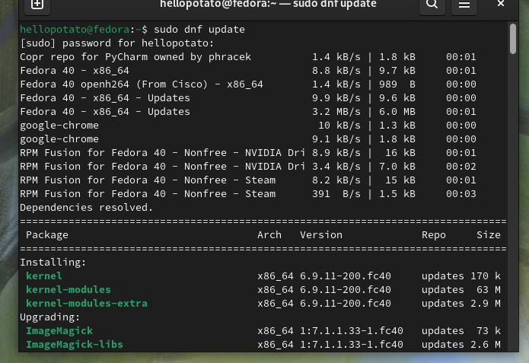

2.Code: Sudo dnf install -y community-mysql-server

Installing the sql server.

3.The sql in first after installed the status is in disable, we need to change it to enable.

Code: sudo systemctl enable mysqld



4.start sql

Code: sudo systemctl start mysqld.service



5.Setting the sql

Code: sudo mysql_secure_installation

6.Login sql

Code: sudo mysql -u root -p

Finish

Example

1. Install git: **sudo dnf install git**

**Example:**

3. Check the data status in the files(no matter its already been managed or not):

**Sudo git status**

4. Save the completed data in the file:

**Sudo git add .**

or

**Sudo git add (data name)**

6. Before upload your files/projects as a version you must set your own identity:

**Sudo git config --global user.email “**[**your@email.com**](mailto:your@email.com)**”**

**Sudo git config --global user.name “your_name”**



If doesn’t set, it will come out like this:

7. Upload the file as a version: **sudo git commit -m ‘version_name’**

Example:

9**. Go back to / delete** the previous version :

**sudo git reset --hard version_id**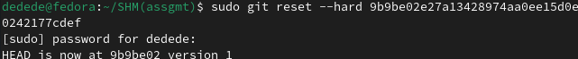

10. Check all the versions no matter that it was been deleted or not:

11. go back to the version that has been deleted:

**sudo git reset --hard version_id**



References

SSH Configuration on Fedora Linux

[How to install, start and connect to SSH Server on Fedora Linux - Linux Tutorials - Learn Linux Configuration](https://linuxconfig.org/how-to-install-start-and-connect-to-ssh-server-on-fedora-linux)

Firewall Configuration on Fedora Linux

<https://www.youtube.com/watch?v=GCDsJpAagUM>

<https://www.atlantic.net/vps-hosting/how-to-install-configure-firewalld-firewall-on-fedora/>

MySQL Configuration on Fedora Linux

<https://youtu.be/n-_nrggWV20?si=UXhRAFb3X8V7_rEP>

Git Configuration & Usage on Fedora Linux

<https://idroot.us/install-git-fedora-39/>